Documentation on Database

Users on the Database:

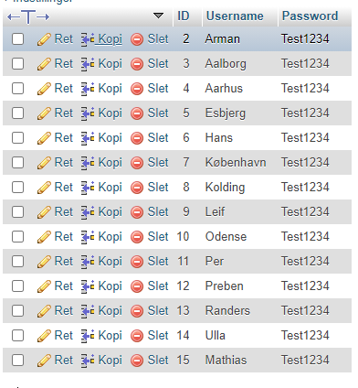

IP Scope (Useable IP addresses)

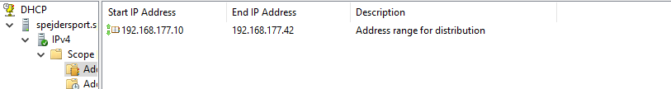

Documentation on Database

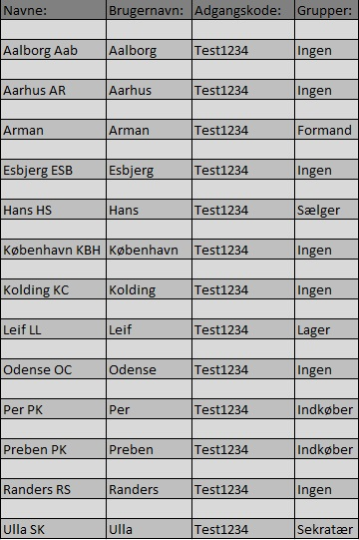Users on the Server: